UNIT-3
Q1) Explain in detail about Mule applications, directories and files structure
A)
When you create a Mule application using Anypoint Studio, it automatically creates a set of folders and files.
These make up the structure of a Mule application.
Understanding this structure is very important for exams and for developing MuleSoft projects.
A Mule Application is basically a project folder that contains everything needed for integration — like configuration files, flows, dependencies, resources, and properties.
The default structure looks like this:

my-mule-app/
│
├── src/
│ ├── main/
│ │ ├── mule/
│ │ │ └── myflow.xml
│ │ ├── java/
│ │ └── resources/
│ │ ├── log4j2.xml
│ │ ├── mule-app.properties
│ │ └── global-config.xml
│ │
│ └── test/
│ ├── mule/
│ └── resources/
├── target/
├── mule-artifact.json
├── pom.xml
└── README.md
2. Important Directories and Files
A. src/main/mule/
- This folder contains all Mule configuration files.
- Each file usually has .xml extension.
- These files define flows, sub-flows, and connectors.
- Example:
myflow.xml → contains flow definitions like HTTP Listener, Logger, and Transform Message components.
Example:
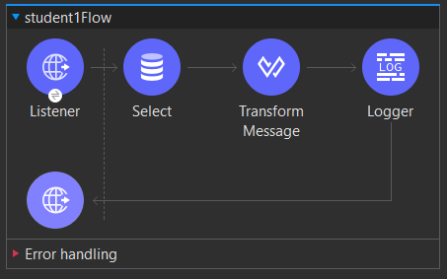
B. src/main/java/
- This folder is used for writing custom Java code that your Mule app needs.
- You can create Java classes or custom functions that are later called from Mule flows.
Example:
public class MyCustomClass {
public static String sayHello(String name) {
return "Hello, " + name;
}
}

C. src/main/resources/
- Stores resources and configuration files used by the app.
- Important files inside this folder:
  - mule-app.properties → Used to define key–value pairs for environment-specific properties (like DB username, URLs).
  - log4j2.xml → Used to configure logging behavior.
  - global-config.xml → Optional; contains shared configurations (like HTTP, Database, or JMS connector settings).
  - any additional resource files (like JSON, CSV, or XML files used for input/output).
Example from mule-app.properties:
http.port=8081
db.username=admin
db.password=1234

D. src/test/
- Used for testing your Mule flows.
- Contains MUnit test cases (Mule Unit testing framework).
- Subfolders:
  - src/test/mule/ → MUnit test flows (.xml files)
  - src/test/resources/ → Supporting resources (like test data files)

E. target/
- This folder is auto-generated when you build the application (using Maven).
- It contains the compiled files and the final deployable package (.jar or .zip).
- You don’t edit this folder manually.

F. mule-artifact.json
- Defines metadata about the Mule application.
- Specifies the runtime version, application name, and required dependencies.
- This file is mandatory for every Mule app.
Example:
{
"minMuleVersion": "4.4.0",
"secureProperties": ["db.password"]
}

G. pom.xml
- Present in every Mule project because Mule uses Maven for dependency management.
- This file lists:
  - The project name
  - The Mule runtime version
  - Any dependencies (like connectors, modules, or libraries)
  - Build plugins

Key Points
- Mule apps follow a standard folder structure for easy management.
- The main logic of the application lies in src/main/mule/.
- The properties and logging configurations are inside src/main/resources/.
- The mule-artifact.json file is mandatory — without it, the app won’t deploy.
- pom.xml handles all dependencies and build configurations.
- target folder is generated automatically during build — not edited manually.

Q2) List and explain the various flow types available in MuleSoft
A)
Flows in MuleSoft
In MuleSoft, a flow is a sequence of steps that processes data from start to end.
Each flow defines how data enters the application, how it is processed, and where it is sent.
Flows are made up of different building blocks like:
- Connectors (for example, HTTP Listener, Database Connector)
- Transformers (for changing data format)
- Components (for logic and control)
- Error Handlers (for managing exceptions)
Flows help us organize our integration logic in a clear and reusable way. A Mule application can have one flow or many flows that work together.

Example:
- One flow may receive a request from an API.
- Another flow may transform the data.
- A third flow may store the data into a database.
So, multiple flows can work together to complete one full business process.

2. Types of Flows in MuleSoft
MuleSoft mainly provides four types of flows:
- Subflow
- Synchronous Flow
- Asynchronous Flow
- Private Flow

1. Subflow
Meaning:
A Subflow is a small, reusable flow that can be called from other flows whenever needed.
It helps you avoid writing the same logic again and again.
Execution:
- It runs synchronously — meaning, the main flow waits until the subflow finishes its work.
- It inherits the error handling of the parent (calling) flow.
Use Case:
Use subflows for repetitive tasks, like logging, validation, or setting variables.

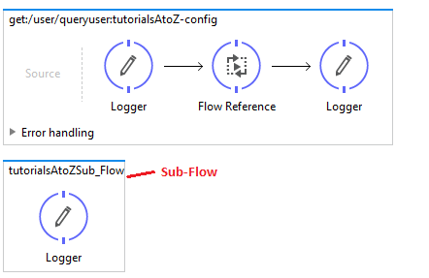
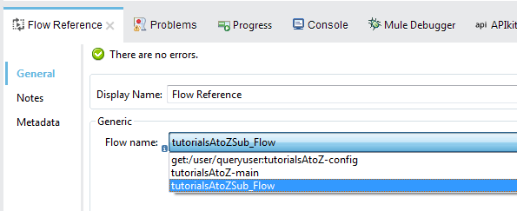

2. Synchronous Flow
Meaning:
A Synchronous Flow behaves like a subflow but has its own error handling.
It runs in the same thread as the parent flow.
Execution:
- It is also synchronous — the main flow waits for it to finish.
- But does not inherit the parent flow’s error handling.
Use Case:
Used when you want transactional processing or when independent error handling is needed but you still want to wait for the result.
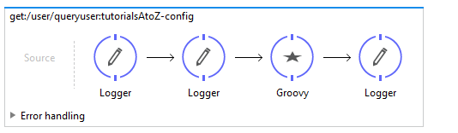
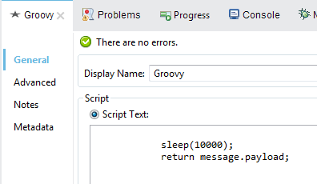

3. Asynchronous Flow
Meaning:
An Asynchronous Flow runs in parallel to the calling flow.
The main flow does not wait for it to finish.
Execution:
- Runs asynchronously, in a different thread.
- Has independent error handling.
- Used for background or long-running tasks.
Use Case:
Best for time-consuming tasks like sending emails, file uploads, or making external API calls — because it doesn’t block the main process.
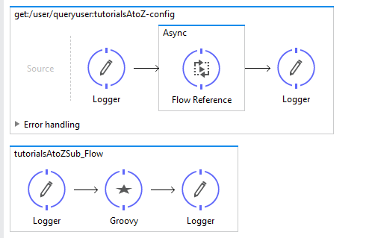


4. Private Flow
Meaning:
A Private Flow is like a normal flow but it does not have a message source (no inbound connector like HTTP Listener).
It is invoked internally by other flows.
Execution:
- Can run synchronously or asynchronously.
- Has its own execution context and error handling (does not share with others).
Use Case:
Used when you want to separate error handling or perform internal processing within the app without exposing it to the outside world.
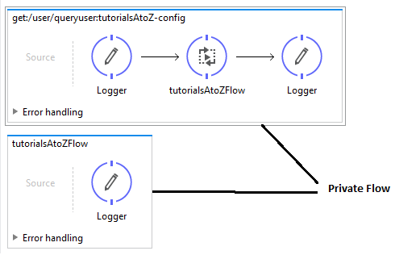
Key Points
- A Flow defines how Mule processes data step-by-step.
- Subflows share the parent’s error handling; synchronous and asynchronous flows don’t.
- Asynchronous flows allow parallel execution.
- Private flows are used internally (no message source).
- Using multiple flows makes the Mule application modular, reusable, and easy to manage.

Q3) How to prepare a request, call a REST API and work on its response
A)
In MuleSoft, we can easily connect our application to an external REST API using the HTTP Request component. This allows us to send requests to external systems, get their responses, and use those responses in our Mule flows.
For example:
We can call a public API like https://jsonplaceholder.typicode.com/users to fetch user data and display it in our browser.

Steps to Create and Configure the Mule Flow
Step 1: Create a New Mule Project
- Open Anypoint Studio.
- Go to File → New → Mule Project.
- Enter the project name — for example: HelloMule.
- Click Finish.
This creates a new Mule application with the required folder structure.
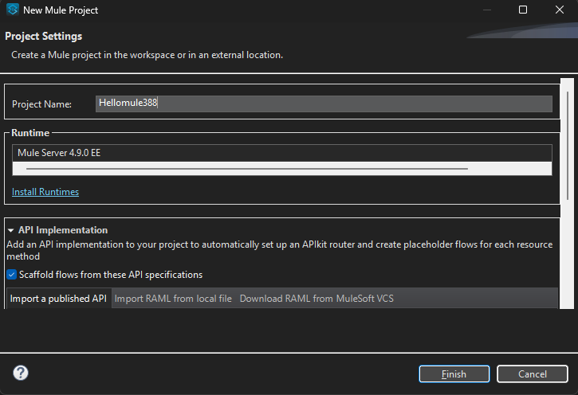
Step 2: Add an HTTP Listener
The HTTP Listener acts as the entry point to your application.
It listens for incoming HTTP requests (like when you open a URL in the browser).
Steps:
- From the Mule Palette, drag the HTTP Listener to the canvas.
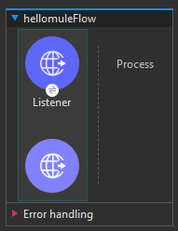
- Click on it and configure it:
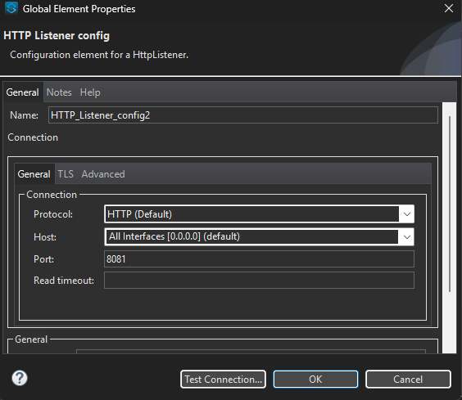
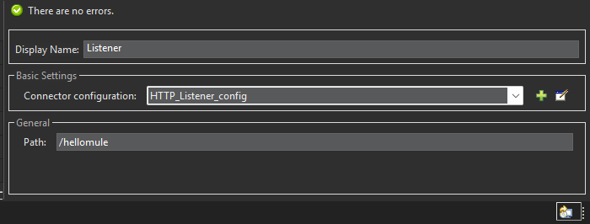
  - Under General → Path: type /hellomule
  - Under Connector Configuration: click + and set:
    - Host: 0.0.0.0
    - Port: 8081
  - Click OK and then Save.
This means your app will listen to requests at:
http://localhost:8081/hellomule

Step 3: Add the HTTP Request Component
The HTTP Request component is used to send a request to an external REST API.
Steps:
- From the Mule Palette, drag the HTTP Request component (from the HTTP module) and place it after the HTTP Listener.
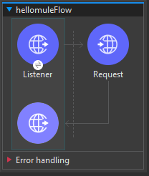
- In the Properties section:
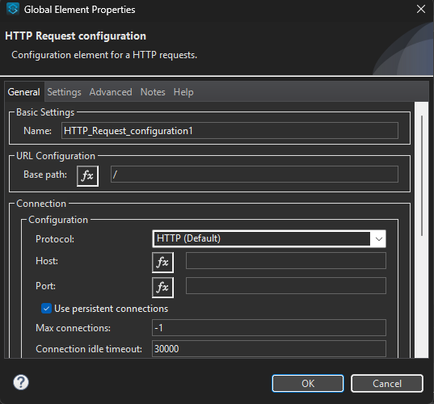
  - Click + next to Connector Configuration → then click OK to accept default settings.
  - Set:
    - Method: GET
    - Path / URL: https://jsonplaceholder.typicode.com/users
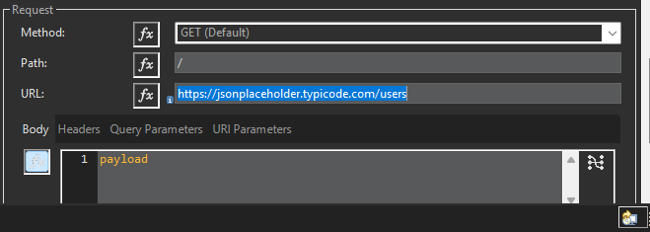
This URL is a public REST API that returns user information in JSON format.

Step 4: Save and Run the Application
- Click File → Save All.
- Right-click on the canvas → choose Run project ‘HelloMule’.
- Wait for the console to display the message:
"DEPLOYED"

Step 5: Test the API Call
Now, open your browser and type:
http://localhost:8081/hellomule
The HTTP Listener will receive this request and trigger the flow. Then, the HTTP Request component will call the external REST API (https://jsonplaceholder.typicode.com/users).
Finally, the response from that API will be displayed in your browser as JSON data.
You’ll see output similar to:
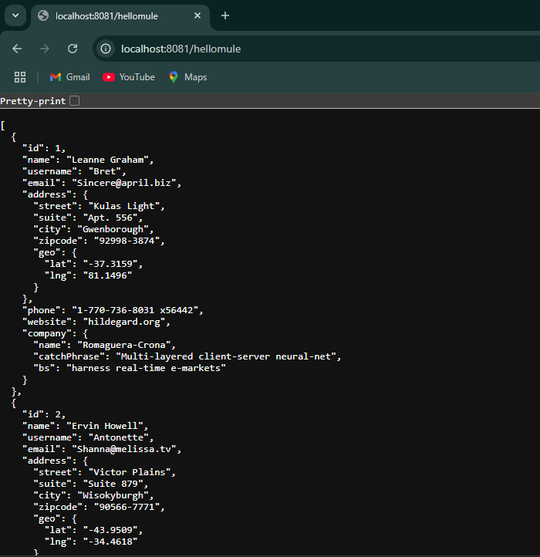

Step 6: Add Query Parameters (Optional)
You can also send query parameters along with the request to get specific results.
Example:
To get only the details of user with ID = 1,
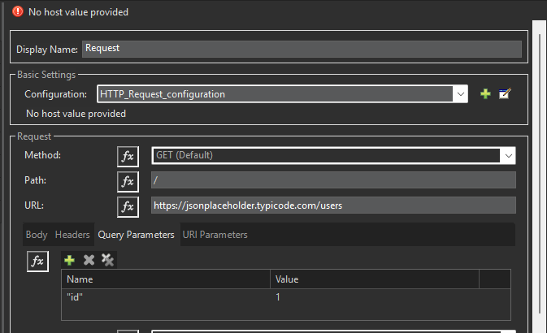
- In the HTTP Request component, go to the Query Parameters section.
- Add:
  - Name: id
  - Value: 1
- Save and re-run the project.
Now open:
http://localhost:8081/hellomule
The response will now show only the data of user with ID 1.
6. Output Example
When you run the project and visit localhost:8081/hellomule,
you’ll see a list of user details like names, emails, and addresses returned by the API.
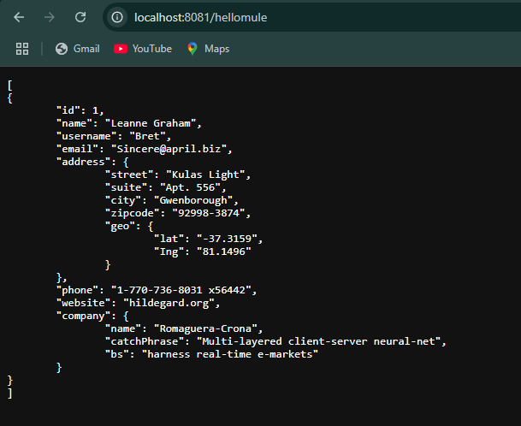

Q4) Describe the concept of event validation in MuleSoft and explain the role of the following validations:
a) Is not null b) Is Number c) Is email
A)

Event Validation in MuleSoft
Event validation in MuleSoft is the process of checking whether the incoming data in a Mule event (like a request payload) meets specific rules or conditions before it is processed further.
MuleSoft provides a built-in Validation Module that helps you easily verify the correctness and completeness of data.
If a validation fails, Mule throws a ValidationException, which can be handled using error handling components.
Purpose of Validation:
- To ensure the incoming data is correct and not empty.
- To prevent invalid or incomplete data from entering the system.
- To improve data integrity and application reliability.

Steps in Event Validation
The Mule application performs validations in a specific order:
- Check if the name is not null.
- Check if the email is in a valid format.
- Check if the marks are a valid number between 0 and 100.
- If all validations pass, the application returns the valid data through a Transform Message component.

Commonly Used Validations in MuleSoft
MuleSoft provides several ready-made validations. The main ones used in this project are:

(a) Is Not Null
Purpose:
This validation checks whether a given value (for example, payload.name) is not null.
If the value is missing or empty, it throws a validation error.
When to Use:
When a field is mandatory (like a customer name or order ID).
Configuration Example:
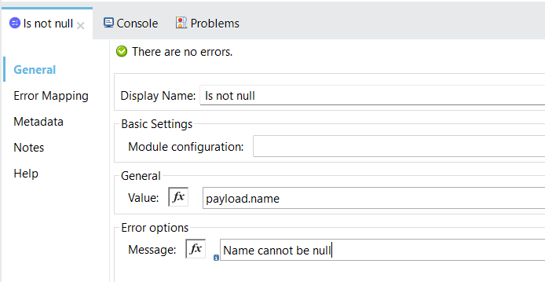
- Value: #[payload.name]
- Message: "Name cannot be null."
Function:
Ensures that the input request includes a value for “name”.
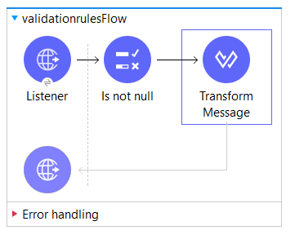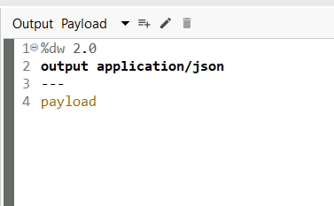
Output:
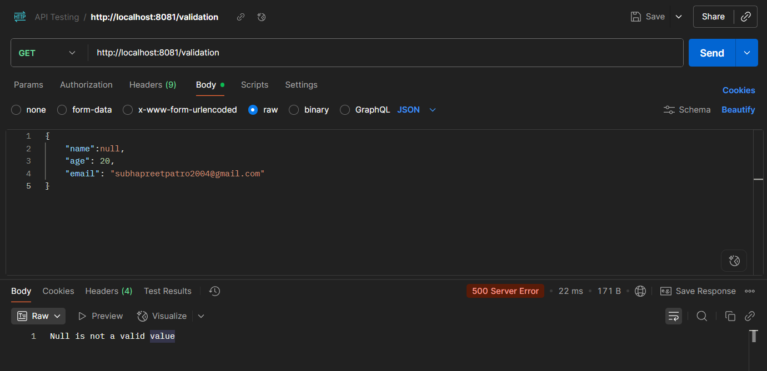
In simple words:
This validation makes sure that something has been entered and it’s not left blank.

(b) Is Email
Purpose:
This validation checks whether a given value is a properly formatted email address.
When to Use:
Whenever you receive email addresses from users or other systems and need to verify they’re in the correct format.
Configuration Example:
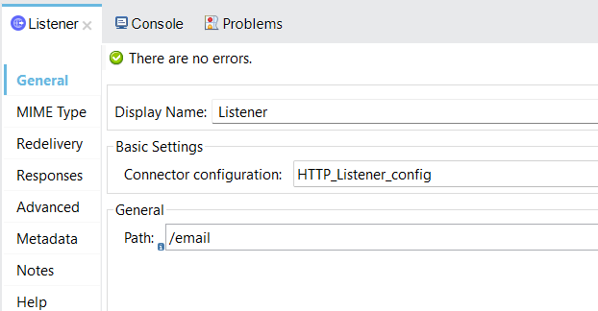

- Value: #[payload.email]
- Message: "Please enter a valid email address."
Function:
Ensures that the email follows standard format rules like example@gmail.com.
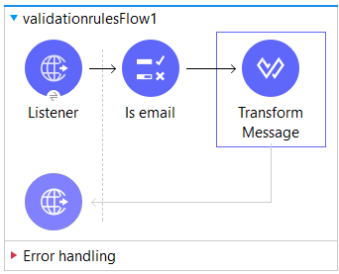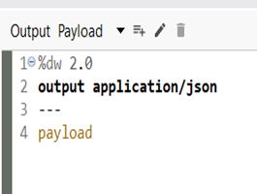

Output:
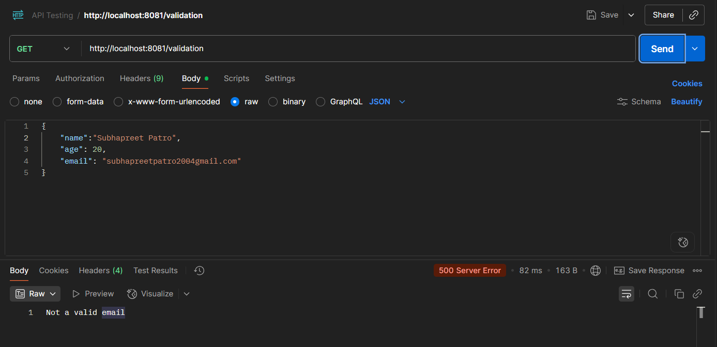
In simple words:
This validation checks that the provided text looks like a real email address (has @ and a valid domain).

(c) Is Number
Purpose:
This validation checks whether the provided value is a number and (optionally) whether it falls within a specified range.
When to Use:
For validating numeric data like marks, age, price, or quantity.
Configuration Example:
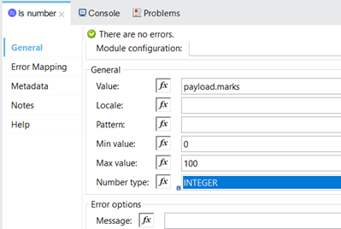
- Value: #[payload.marks]
- Message: "Please enter valid marks."
- Minimum Value: 0
- Maximum Value: 100
Function:
Ensures that the marks entered are numeric and within the range 0–100.
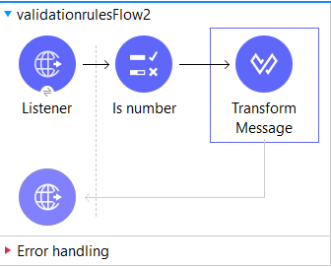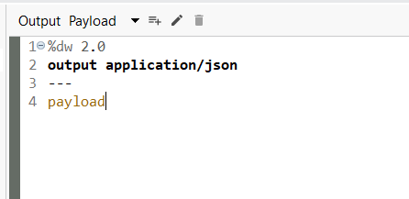
Output:
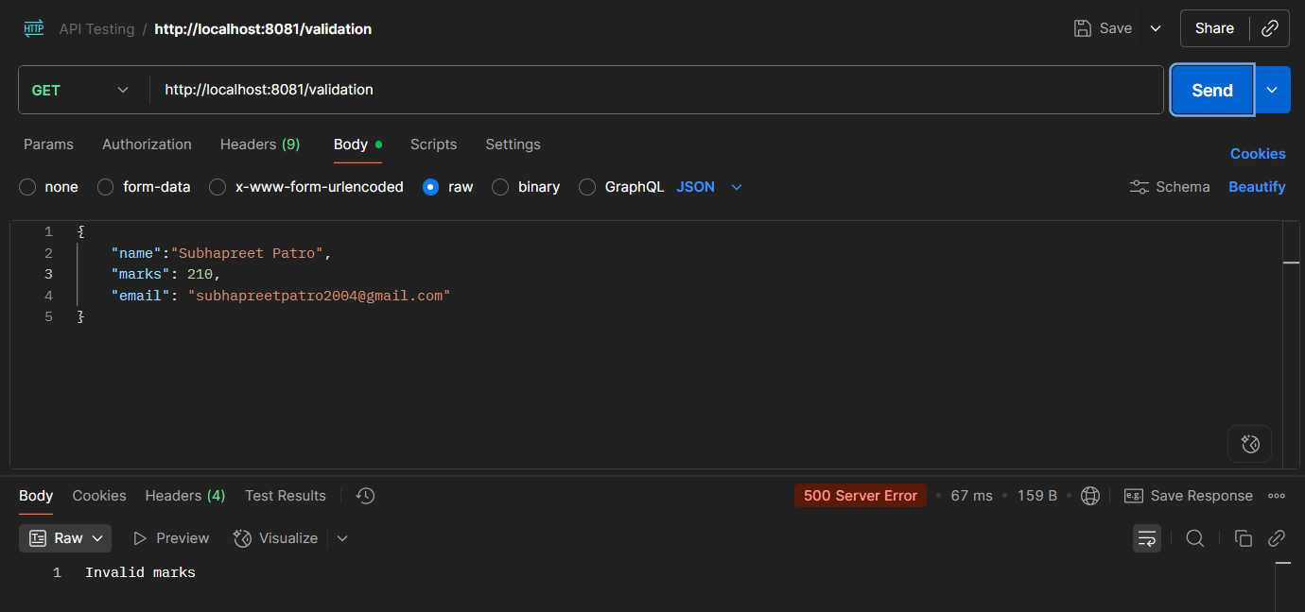
In simple words:
This validation ensures the data is a number and lies within the allowed range.

Q5) With the help of an example explain how to consume a REST service.
A)
REST (Representational State Transfer) is an architectural style used for designing web services that communicate over the HTTP protocol. It allows different systems to interact with each other using standard web methods.
Key Concepts of REST
- Client-Server Architecture:
The client (e.g., web app or mobile app) sends requests, and the server provides responses.
- Statelessness:
Each request from the client to the server must contain all the information needed to process it. The server does not store any client session information between requests.
- Resources:
Everything in REST is treated as a resource, such as a user, product, or order.
Each resource is identified by a unique URI (Uniform Resource Identifier).
- HTTP Methods Used:
  - GET – Retrieve data
  - POST – Create a new resource
  - PUT – Update an existing resource
  - DELETE – Remove a resource
- Data Formats:
REST commonly uses JSON or XML to exchange data, with JSON being the most popular due to its simplicity.

For example:
We can call a public API like https://jsonplaceholder.typicode.com/users to fetch user data and display it in our browser.

Steps to Create and Configure the Mule Flow
Step 1: Create a New Mule Project
- Open Anypoint Studio.
- Go to File → New → Mule Project.
- Enter the project name — for example: HelloMule.
- Click Finish.
This creates a new Mule application with the required folder structure.

Step 2: Add an HTTP Listener
The HTTP Listener acts as the entry point to your application.
It listens for incoming HTTP requests (like when you open a URL in the browser).
Steps:
- From the Mule Palette, drag the HTTP Listener to the canvas.

- Click on it and configure it:


  - Under General → Path: type /hellomule
  - Under Connector Configuration: click + and set:
    - Host: 0.0.0.0
    - Port: 8081
  - Click OK and then Save.
This means your app will listen to requests at:
http://localhost:8081/hellomule

Step 3: Add the HTTP Request Component
The HTTP Request component is used to send a request to an external REST API.
Steps:
- From the Mule Palette, drag the HTTP Request component (from the HTTP module) and place it after the HTTP Listener.

- In the Properties section:

  - Click + next to Connector Configuration → then click OK to accept default settings.
  - Set:
    - Method: GET
    - Path / URL: https://jsonplaceholder.typicode.com/users

This URL is a public REST API that returns user information in JSON format.
Step 4: Save and Run the Application
- Click File → Save All.
- Right-click on the canvas → choose Run project ‘HelloMule’.
- Wait for the console to display the message:
"DEPLOYED"

Step 5: Test the API Call
Now, open your browser and type:
http://localhost:8081/hellomule
The HTTP Listener will receive this request and trigger the flow. Then, the HTTP Request component will call the external REST API (https://jsonplaceholder.typicode.com/users).
Finally, the response from that API will be displayed in your browser as JSON data.
You’ll see output similar to:

Step 6: Add Query Parameters (Optional)
You can also send query parameters along with the request to get specific results.
Example:
To get only the details of user with ID = 1,

- In the HTTP Request component, go to the Query Parameters section.
- Add:
  - Name: id
  - Value: 1
- Save and re-run the project.
Now open:
http://localhost:8081/hellomule
The response will now show only the data of user with ID 1.
6. Output Example
When you run the project and visit localhost:8081/hellomule,
you’ll see a list of user details like names, emails, and addresses returned by the API.


Q6) How to consume a SOAP web service in Mule using Anypoint?
A)
To consume a SOAP web service means your Mule application acts as a client to another system’s SOAP service:
- It sends a SOAP request (using a WSDL definition)
- Receives a SOAP response
- Processes that response in your flow
Using Anypoint Studio + the built-in Web Service Consumer connector, you can call an external SOAP service by providing its WSDL and then invoking one of its operations.

Prerequisites
Before you start:
- You need the WSDL URL of the SOAP web service you want to consume. For example, you can use the public service from W3Schools for temperature conversion. (https://www.w3schools.com/xml/tempconvert.asmx)
- You should have Anypoint Studio installed and set up to build a Mule application.

Step-by-step: How to consume the SOAP web service in Anypoint Studio
Step 1: Create a new Mule project
- Open Anypoint Studio.
- Choose File → New → Mule Project.
- Give it a name (e.g., soap_webservice_consumer).
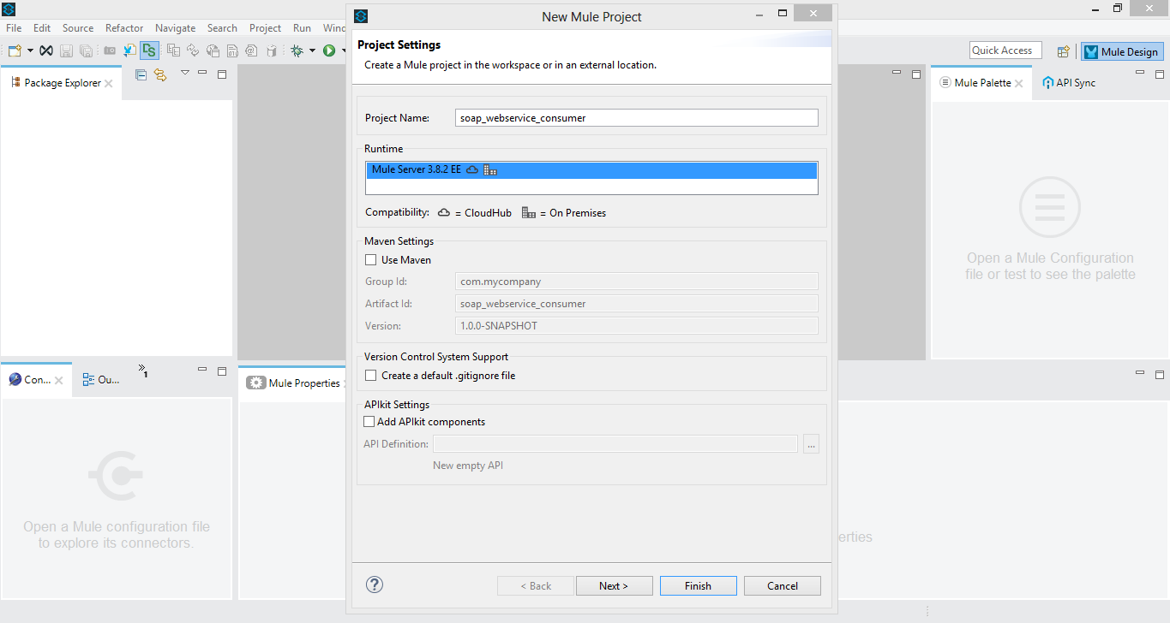
Step 2: Add an HTTP Listener (entry point for your flow)
- On the canvas, drag the HTTP Listener connector from the Mule Palette.
- Configure it so that it listens on a host and port (default is fine) and has a path (e.g., /).
- This will be how you trigger your Mule flow (for example, via a browser or HTTP client).
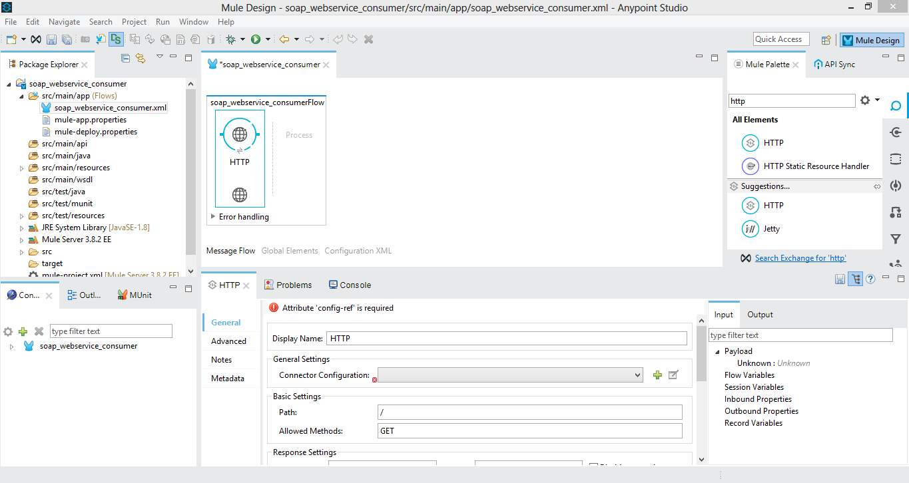
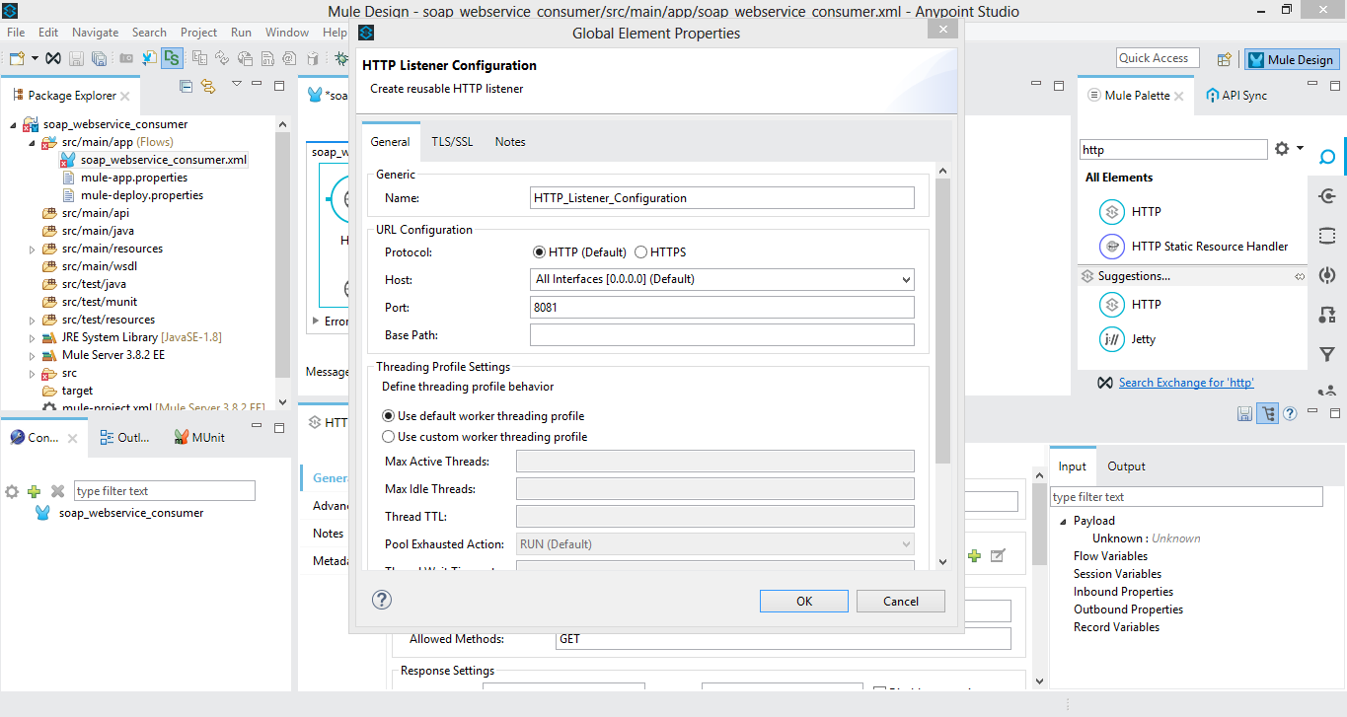
Step 3: Add the Web Service Consumer connector
- From the Mule Palette, drag the Web Service Consumer connector into your flow (after the HTTP Listener).
- Click to configure it:
  - Click the global element button (green “+”) for the connector configuration.
  - Set the WSDL Location to the URL of the SOAP service WSDL (https://www.w3schools.com/xml/tempconvert.asmx?wsdl).
  - After you set the WSDL, the connector will automatically populate Service, Port and Address fields (you can choose among them if multiple).
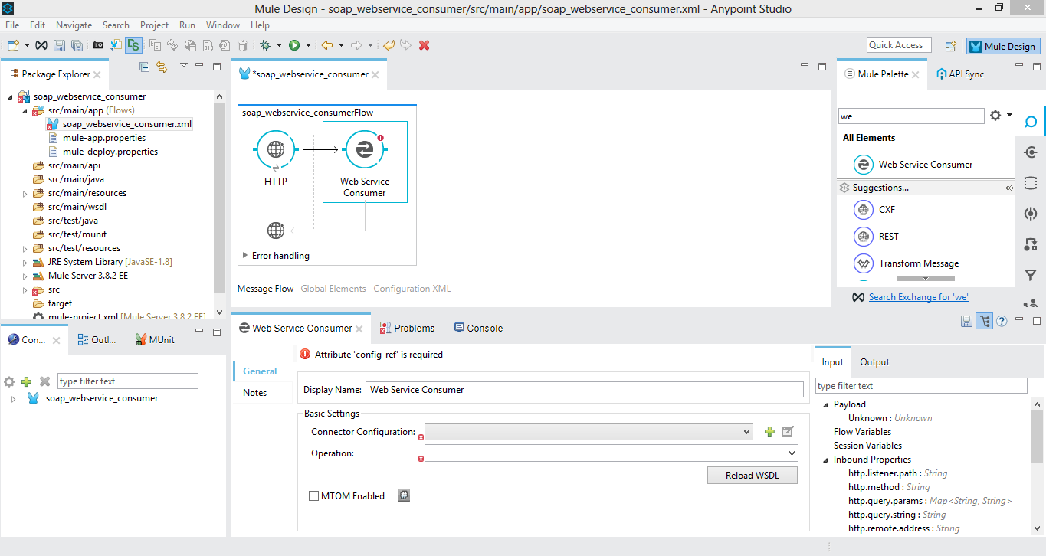
Step 4: Choose the operation you want to call
- In the Web Service Consumer configuration, after the connector is set up, you will be able to choose the operation (method) from the dropdown list exposed by the WSDL.
  - Example: For the temperature conversion service the operations are CelsiusToFahrenheit or FahrenheitToCelsius.
- Select the operation you need (say CelsiusToFahrenheit).
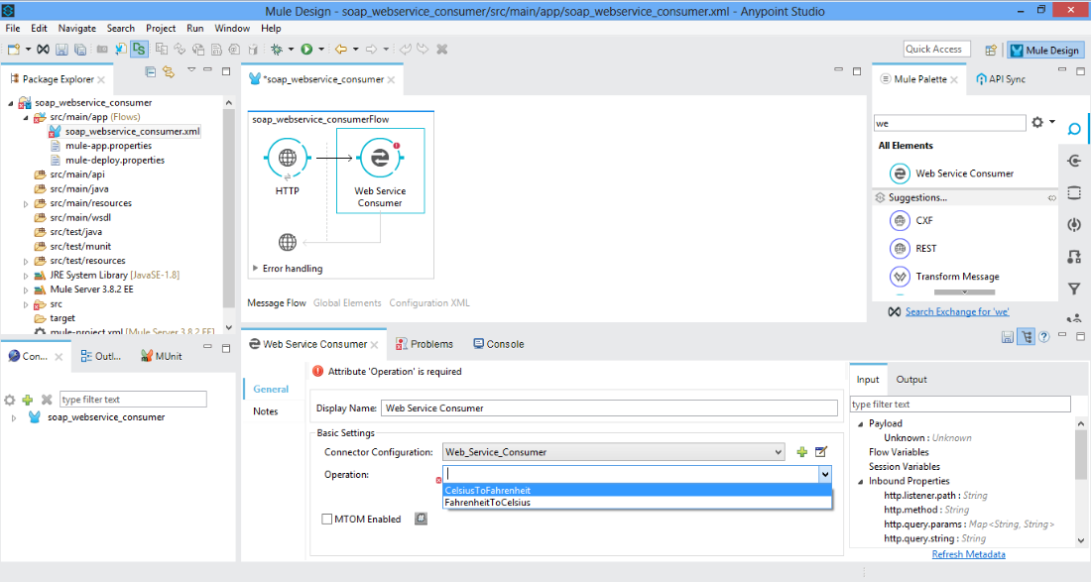
Step 5: Map the input parameters
- To pass input from the HTTP Listener to the SOAP call:
  - For example, use a Variable component to capture a query parameter from the HTTP request (e.g., ?temp=34).
  - Then use a Transform Message component (or DataWeave) to map the variable into the SOAP request body. For example, set ns0:Celsius to the value of your variable.
- This ensures that when you call the SOAP service, you pass the correct input.
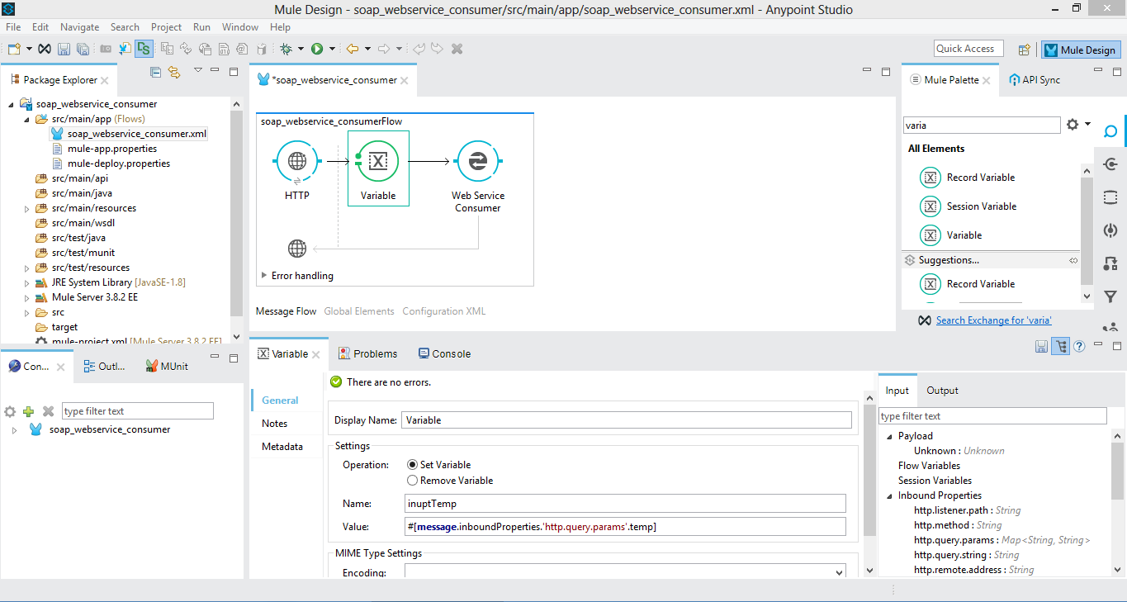
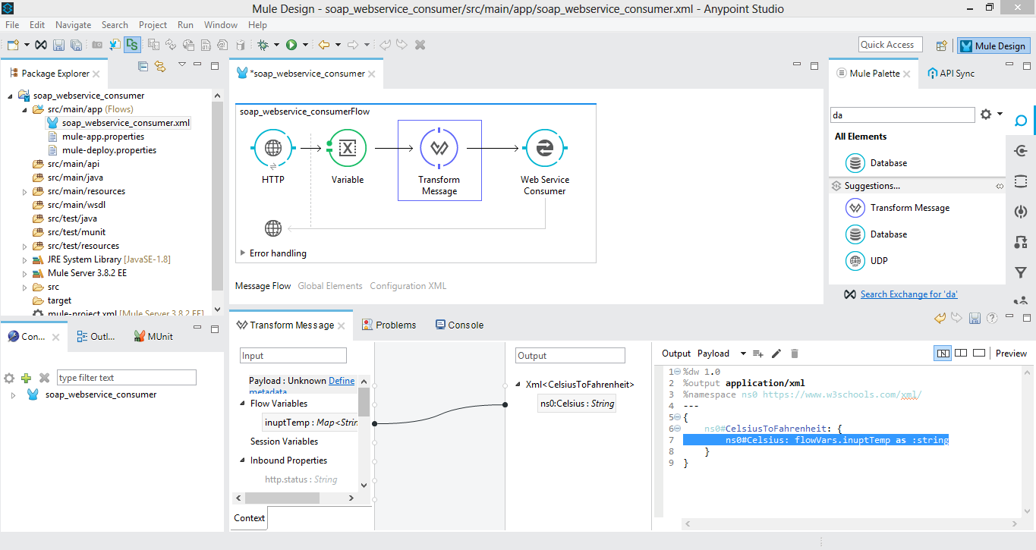
Step 6: Deploy and test
- Save all changes.
- Run the Mule application (in Studio, click Run).
- Open a browser or HTTP client and hit the HTTP Listener endpoint with the query param. Example: http://localhost:8081/?temp=34
- The flow will: HTTP Listener → Web Service Consumer (call SOAP service) → get SOAP response → return that response to the caller.
- You should see the converted temperature (e.g., Fahrenheit value) returned in the response.
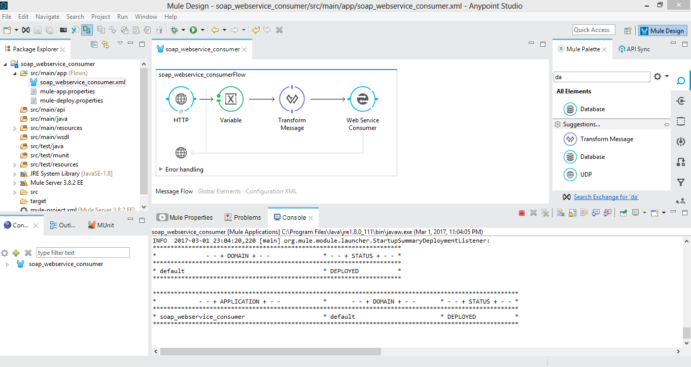

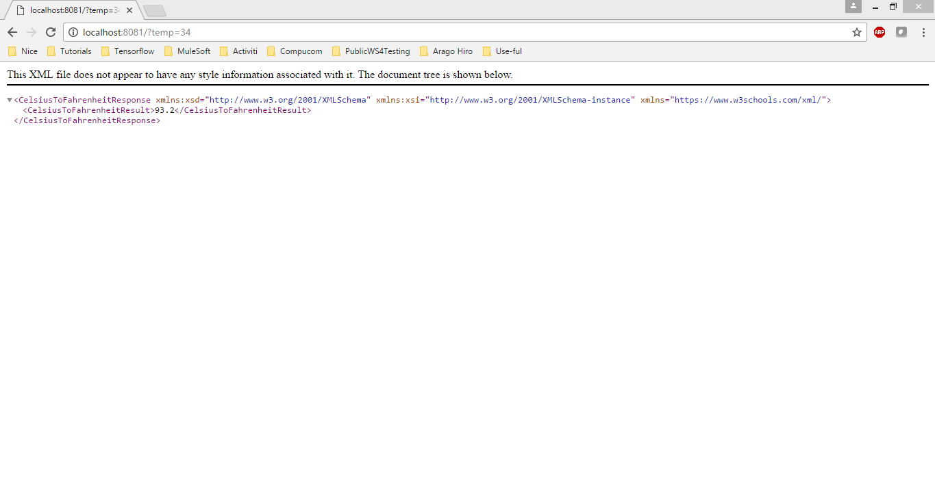
Working of the flow
- The WSDL (Web Services Description Language) describes how to talk to the SOAP service: what operations are available, what inputs they take, what outputs they give.
- The Web Service Consumer connector uses that WSDL to generate the correct SOAP envelopes and handle communication.
- The HTTP Listener provides a user‐friendly way to trigger the flow (via HTTP).
- Transforming the input and mapping the output lets you integrate the SOAP service into your Mule application logic.

Q7) Illustrate the configuration and working of a Choice Router in Anypoint Studio
A)
Introduction to Choice Router
In MuleSoft, a Choice Router is used to make decisions within a flow — similar to an if–else statement in programming.
It helps in routing the message to different paths based on certain conditions or expressions.
Each condition is written using a DataWeave (DW) expression, and there is always a default path that runs when no condition matches.
For example, we can use a Choice Router to determine a student’s grade based on their marks.
Steps to Configure the Choice Router
Step 1: Create a New Mule Project
- Open Anypoint Studio.
- Go to File → New → Mule Project.
- Enter the project name as StudentGrades.
- Click Finish.
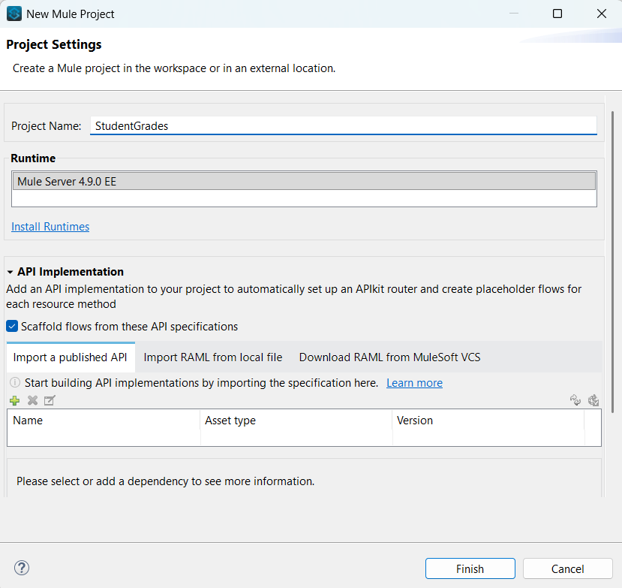
Purpose:
To create a new Mule application where the flow will be designed.

Step 2: Add an HTTP Listener
- From the Mule Palette, drag and drop an HTTP Listener component onto the canvas.
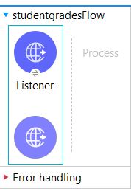
- In the Properties tab, configure:
  - Path: /grades
  - Port: 8081
- Click + next to Connector Configuration and keep:
  - Host: 0.0.0.0
  - Port: 8081
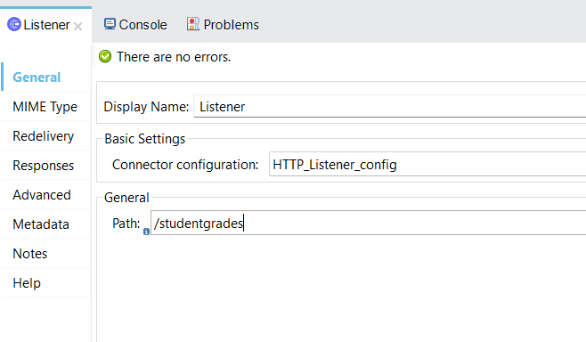
Purpose:
The HTTP Listener acts as the entry point of the application.
It receives requests containing student marks in the payload (for example, through Postman).

Step 3: Add a Set Variable Component
- Drag a Set Variable component right after the HTTP Listener.
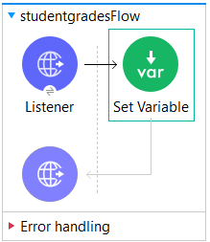
- Configure:
  - Name: grade
  - Value: #[payload.grade]
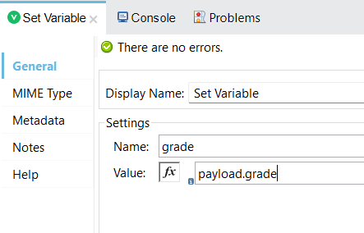
Purpose:
To extract the marks (from the incoming request payload) and store it in a variable named grade.
This variable will be used by the Choice Router to decide the grade.

Step 4: Add and Configure the Choice Router
- From the Mule Palette, drag the Choice component and place it after the Set Variable.
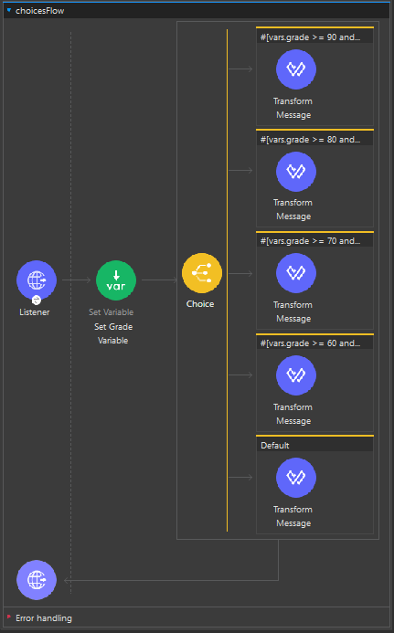
- Click on the Choice Router and define multiple When conditions and a Default route.
Each condition will check the student’s marks range using DataWeave expressions like:
Condition (DW Expression) | Result / Action
#[vars.grade >= 90] | Return “Grade: A”
#[vars.grade >= 80] | Return “Grade: B”
#[vars.grade >= 70] | Return “Grade: C”
#[vars.grade >= 60] | Return “Grade: D”
#[vars.grade >= 50] | Return “Grade: E”
#[vars.grade >= 40] | Return “Pass”
Default | Return “Fail”

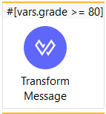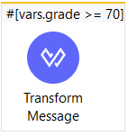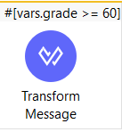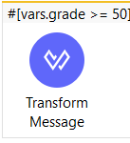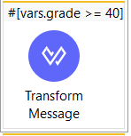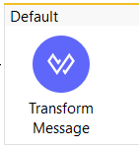
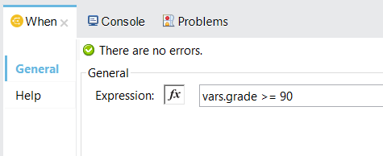
Purpose:
The Choice Router evaluates each condition one by one.
As soon as a condition matches, the flow goes through that path and executes the respective message transformation.

Step 5: Add Transform Message Components
For each branch of the Choice Router:
- Drag a Transform Message component.
- Inside it, set the message you want to return to the user, such as:
output text/plain
---
"Grade: A"
or "Grade: B", "Pass", "Fail", etc.
Purpose:
To send a clear text response showing the grade based on the marks.

Step 6: Run and Test the Application
- Click Run Project StudentGrades from the toolbar.
- Wait until you see "DEPLOYED" in the Console.
- Open Postman (or any API client).
- Send a POST request to:
- http://localhost:8081/grades
with the JSON body:
{
"grade": 85
}
- Check the response.
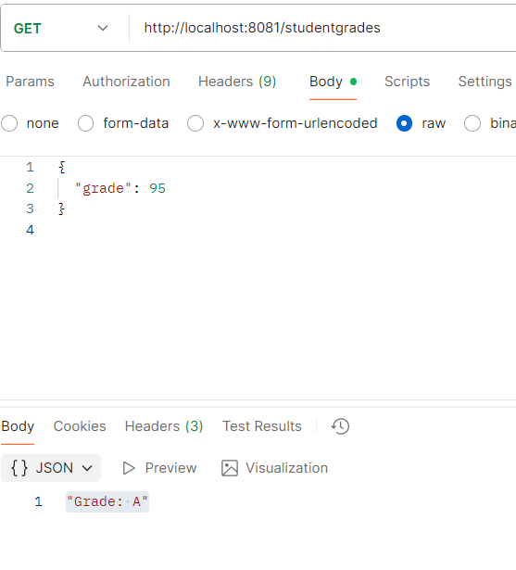
Example Outputs:
Input (Marks) | Output (Response)
95 | Grade: A
82 | Grade: B
72 | Grade: C
65 | Grade: D
55 | Grade: E
45 | Pass
30 | Fail

Working of the Choice Router
- When a request is received, Mule reads the marks value.
- The marks are stored in a variable (vars.grade).
- The Choice Router checks each condition in order:
  - If marks ≥ 90 → flow goes to Grade A branch.
  - Else if marks ≥ 80 → flow goes to Grade B branch, and so on.
- If no condition matches, the Default route executes and returns “Fail”.
- Finally, the Transform Message component sends the grade response back to the user.

Q8) Create a mule project to calculate the student grade using choice router
A)
Steps to Configure the Choice Router
Step 1: Create a New Mule Project
- Open Anypoint Studio.
- Go to File → New → Mule Project.
- Enter the project name as StudentGrades.
- Click Finish.

Purpose:
To create a new Mule application where the flow will be designed.

Step 2: Add an HTTP Listener
- From the Mule Palette, drag and drop an HTTP Listener component onto the canvas.

- In the Properties tab, configure:
  - Path: /grades
  - Port: 8081
- Click + next to Connector Configuration and keep:
  - Host: 0.0.0.0
  - Port: 8081

Purpose:
The HTTP Listener acts as the entry point of the application.
It receives requests containing student marks in the payload (for example, through Postman).

Step 3: Add a Set Variable Component
- Drag a Set Variable component right after the HTTP Listener.

- Configure:
  - Name: grade
  - Value: #[payload.grade]

Purpose:
To extract the marks (from the incoming request payload) and store it in a variable named grade.
This variable will be used by the Choice Router to decide the grade.

Step 4: Add and Configure the Choice Router
- From the Mule Palette, drag the Choice component and place it after the Set Variable.

- Click on the Choice Router and define multiple When conditions and a Default route.
Each condition will check the student’s marks range using DataWeave expressions like:
Condition (DW Expression) | Result / Action
#[vars.grade >= 90] | Return “Grade: A”
#[vars.grade >= 80] | Return “Grade: B”
#[vars.grade >= 70] | Return “Grade: C”
#[vars.grade >= 60] | Return “Grade: D”
#[vars.grade >= 50] | Return “Grade: E”
#[vars.grade >= 40] | Return “Pass”
Default | Return “Fail”



Purpose:
The Choice Router evaluates each condition one by one.
As soon as a condition matches, the flow goes through that path and executes the respective message transformation.

Step 5: Add Transform Message Components
For each branch of the Choice Router:
- Drag a Transform Message component.
- Inside it, set the message you want to return to the user, such as:
output text/plain
---
"Grade: A"
or "Grade: B", "Pass", "Fail", etc.
Purpose:
To send a clear text response showing the grade based on the marks.

Step 6: Run and Test the Application
- Click Run Project StudentGrades from the toolbar.
- Wait until you see "DEPLOYED" in the Console.
- Open Postman (or any API client).
- Send a POST request to:
- http://localhost:8081/grades
with the JSON body:
{
"grade": 85
}
- Check the response.

Example Outputs:
Input (Marks) | Output (Response)
95 | Grade: A
82 | Grade: B
72 | Grade: C
65 | Grade: D
55 | Grade: E
45 | Pass
30 | Fail

Q9) What are Multicast Events in Mule? Explain their working with an example
A)
Multicast Events in Mule
In Mule, a multicast event refers to a scenario where one incoming event/message is sent to multiple routes or destinations at the same time (in parallel), instead of just one path.
- This is useful when one request must be processed by several systems/services simultaneously (e.g., logging, analytics, external system calls) rather than a single sequential path.
- The pattern used is often called Scatter-Gather (also known as “fan-out / fan-in”) in enterprise integration patterns.
- In Mule, the Scatter-Gather router is used to implement this multicasting of events: it sends the same event to multiple “routes,” waits for all of them to finish, and then aggregates their responses into a single event for further processing.
So, in summary: multicast event = one message → many parallel paths → collect responses → continue.

Why Use Multicast (Scatter-Gather) in Mule
Some of the key benefits and reasons:
- Parallel execution: Because each route executes in its own thread, the time to complete the operation is less than doing the routes sequentially. For example, if route A takes 5s and route B takes 6s, doing them in parallel means roughly 6s, instead of ~11s.
- Multiple system calls: If your integration needs to call multiple external systems (APIs, databases, file systems) based on one incoming request, you can multicast once instead of chaining.
- Aggregated result: After the parallel calls complete, you can collect all responses into one combined payload — useful when you need to supply a unified response or combine data from various systems.
- Fault tolerance: Because routes run independently, a failure in one doesn’t necessarily stop the others from executing (depending on configuration). The Scatter-Gather router handles errors in a controlled way via a CompositeRoutingException.

3. How Scatter-Gather Works (Step by Step)
Here’s a simplified working explanation of the router’s internals and what happens when a multicast event is processed:
- The incoming Mule event arrives at the Scatter-Gather component.
- The component clones or passes the event to each route defined under the Scatter-Gather. Each route may contain processors (connectors, flows, transformations).
- All routes start in parallel (each route in its own thread) — not one after the other. This is key for performance.
- Each route executes its logic and completes (successfully or with error).
- After all routes finish (or a configured timeout occurs), Scatter-Gather aggregates the results (payloads, attributes, variables) from each route into a single Mule event.
- That aggregated event is then passed to the next component in the flow for further processing.
- Error handling: If any routes failed and the errors were not handled internally, the router throws a MULE:COMPOSITE_ROUTING error, which contains information about all route failures and successful routes.

4. Example to Illustrate
Let’s illustrate with a simple example (based on the article) that you could use in an exam:
Scenario:
You have a request asking for “price list of a product” and you need to get price data from two online vendors in parallel, and then send back the combined list to the caller.
Configuration Steps:
- HTTP Listener
  - Set up an HTTP Listener at path /getPrices, port 8081.
  - This receives the incoming request.
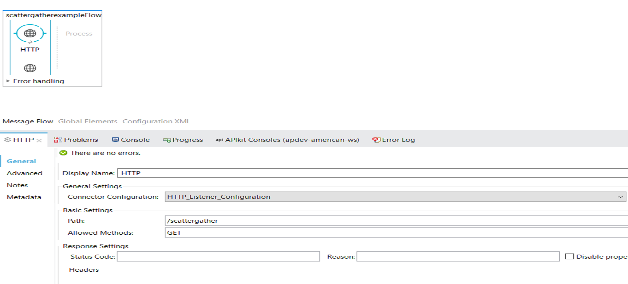

- Scatter-Gather Router
  - After the HTTP Listener, add a Scatter-Gather component to the flow.
This router will send the same incoming Mule event to multiple routes in parallel, and then combine all the results into a single response.
  - In this example, there are four parallel routes, as shown in the diagram:
Route 1: File System
    - Reads data from a File source or writes to a file (depending on configuration).
    - Used for storing or fetching data from the local file system.
Route 2: Web Service Consumer
    - Calls an external SOAP or REST Web Service using the Web Service Consumer connector.
    - A Transform Message component follows to convert the service’s response into a unified format.
Route 3: JMS (Java Messaging Service)
    - Sends or receives messages from a JMS queue or topic.
    - This route allows communication with messaging systems such as ActiveMQ or IBM MQ.
Route 4: HTTP Request
    - Calls an external HTTP service or API using the HTTP Request connector.
    - After receiving the response, a Transform Message component formats the result.
Once all routes finish executing, the Scatter-Gather automatically aggregates the responses from all four routes and passes the combined result to the final Transform Message component, which prepares the overall response to be sent back to the requester.
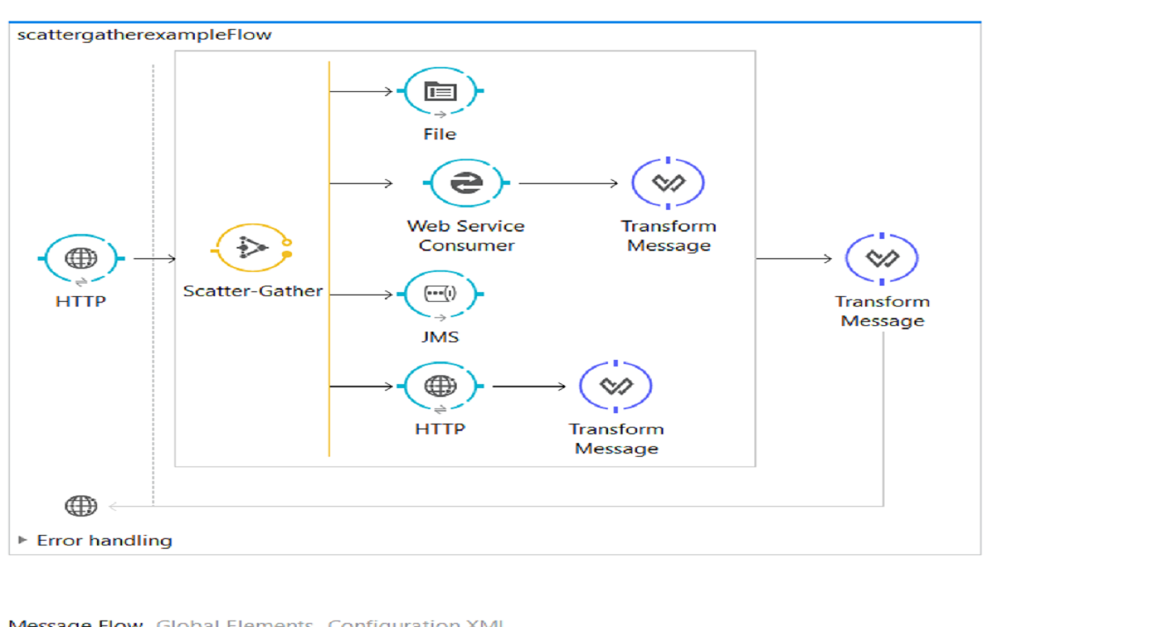
- Aggregation & Output
  - After the Scatter-Gather, add a Transform Message to combine both responses into one payload (for example, flattening into an array or merging).
  - Then send the combined payload back via HTTP Response.
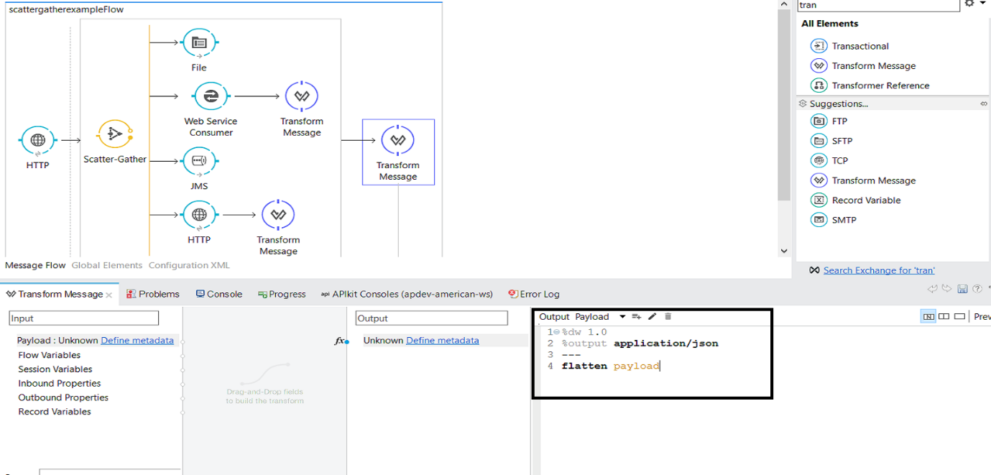
Testing:
- You call http://localhost:8081/getPrices in Postman.
- Mule sends the same request in parallel to both vendor A and vendor B.
- When both responses (or all routes) complete, Mule aggregates them and returns a unified response such as:
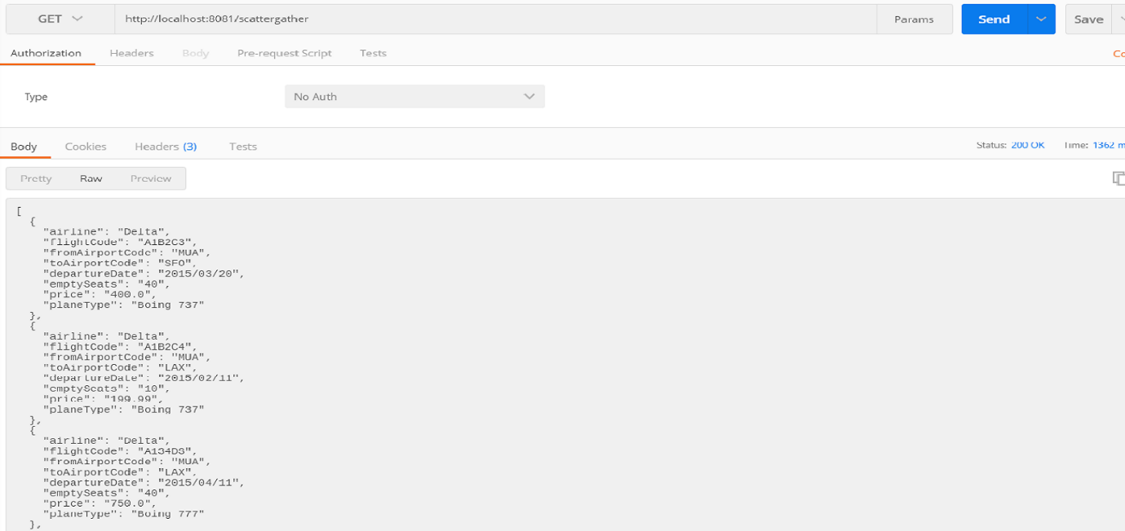
Key points:
- Routes execute in parallel, so it’s faster than sequential processing.
- If vendor B fails but vendor A succeeds, you still get vendor A’s result (unless you configured strict failure).
- The aggregated result is passed onward in the flow.
- You need at least two routes configured for Scatter-Gather, otherwise the app may throw an error.

Q10) Explain the working of Event Subflows in Mule 4. Mention their execution behaviour and error handling.
A)
Event Subflows in Mule 4
In Mule 4, a Subflow is a reusable section of logic that can be called from multiple main flows.
It helps developers avoid repeating the same logic in different places.
Think of it as a function in a programming language — you define it once, and then you can call it whenever needed.

Definition
A Subflow in MuleSoft is a type of flow that:
- Does not have a message source (like an HTTP Listener).
- Cannot be triggered directly by an external request.
- Must be called from another flow using the Flow Reference (Flow-Ref) component.

Purpose of Using Subflows
- To reuse common logic (like logging, validation, or data transformation).
- To simplify complex flows by breaking them into smaller, readable units.
- To maintain consistency and make the application easier to manage.

Example Scenario
Suppose you are building an application that processes orders.
Every order must:
- Validate input data,
- Log the transaction, and
- Send a confirmation message.
Instead of writing the logging or validation logic in multiple flows, you can define them once as a Subflow and reuse them wherever needed.

Example Flow Design
MainFlow → Flow-Ref (calls LogSubFlow) → Other Components
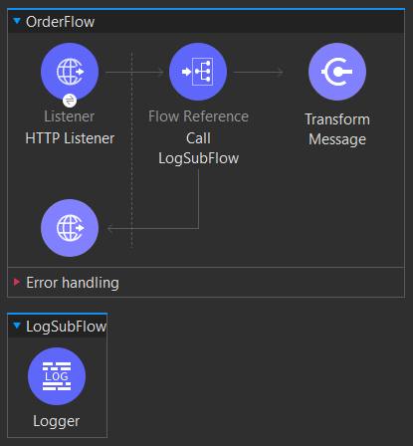
In this example:
- The OrderFlow receives a request using an HTTP Listener.
- It calls LogSubFlow using the Flow-Ref component.
- The subflow logs the message and returns control back to the main flow.

Execution Behavior of Subflows
Subflows have a synchronous execution behavior.
This means:
- When a flow calls a subflow, the main flow pauses until the subflow finishes executing.
- The subflow runs in the same thread as the calling flow.
- After execution, control returns back to the calling flow and continues from where it left off.
In simple terms:
A subflow executes inline with the main flow — just like a function call.

Execution Flow Diagram
Main Flow
│
├──> Flow-Ref → Subflow executes
│
└──> Returns to Main Flow after completion

Error Handling in Subflows
- A Subflow does not have its own error handler.
- It inherits the error handling of the calling flow (the main flow).
- If an error occurs inside the subflow, it will be propagated back to the main flow.
- The main flow’s On Error Continue or On Error Propagate block will handle it.

Example: Error Handling
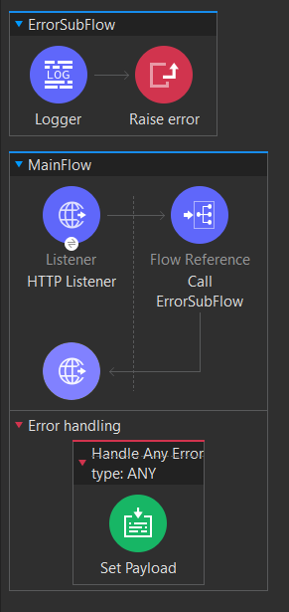

Explanation:
- When ErrorSubFlow raises an error, it doesn’t handle it by itself.
- The error is passed back to the main flow’s error handler.
- The On Error Propagate block catches it and returns an error response.

Advantages of Using Subflows
-Reusability: Common logic can be reused in multiple flows.
-Maintainability: Easier to update logic in one place instead of many.
-Modularity: Improves code organization.
-Performance: Runs within the same thread (no new thread creation).

